LAMPIRAN R 8.1


No. Sebut Harga: UTeM/
BORANG KELULUSAN PERMOHONAN PEROLEHAN

Maklumat Peruntukan:

Bil. | Bekalan/Perkhidmatan/Kerja | Anggaran Seunit [A] | Kuantiti [B] | Anggaran Jumlah Harga  [C] = [A] x [B] | KW | Kod PTj | Kepala Vot
 |  |  |  | RM0.00
 |  |  |  | RM0.00
 |  |  |  | RM0.00
 |  |  |  | RM0.00
 |  |  |  | RM0.00
 |  |  |  | RM0.00
 |  |  |  | RM0.00
 |  |  |  | RM0.00
 |  |  |  | RM0.00
 |  |  |  | RM0.00
 |  |  |  | RM0.00
 |  |  |  | RM0.00
 |  |  |  | RM0.00
 |  |  |  | RM0.00
 |  |  |  | RM0.00
 |  |  |  | RM0.00
JUMLAH |  | RM0.00 |  | RM0.00

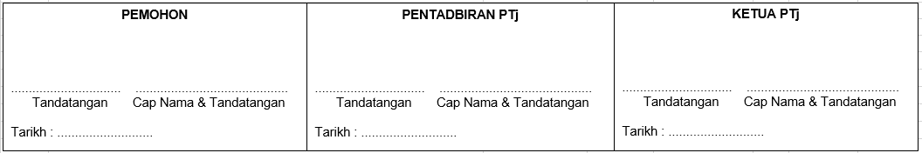
Muka Surat 1 Daripada 1

